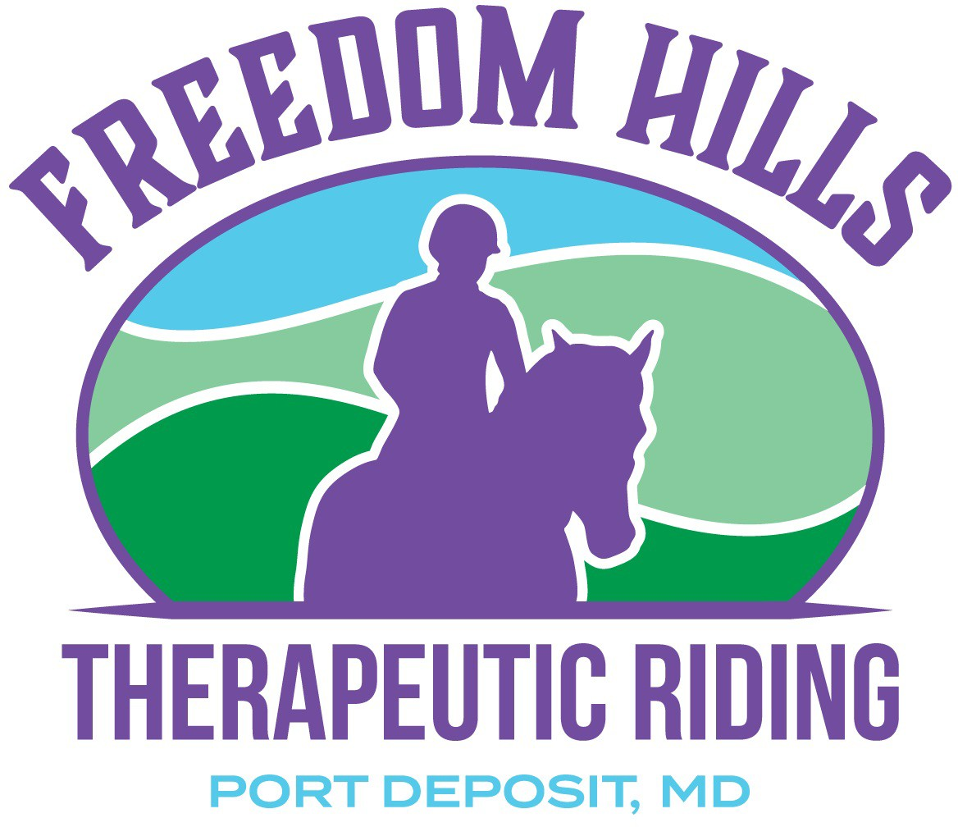

Vendor Application

Contact Information
Business Name
Contact Name
Street Address
City, State, ZIP
Work Phone
Cell or Home Phone
E-Mail Address

Detailed Description of Business / Craft

Booth Space - 8 or 10’ table (you supply) $25.00 + Donation for FHTRP

Person to Notify in Case of Emergency
Name
Street Address
City, State, ZIP Code
Cell Phone
Work Phone

Email: fhtrp@Freedomhills.org

LIABILITY WAIVER I, the registrant or parent/guardian of the registrant, agrees that I will abide by the rules of Freedom Hills TRP as set forth in the invitation to participate letter. Recognizing the possibility of physical injury associated with the activity and in consideration of Freedom Hills TRP employees, officers, directors, agents, successors and assigns of said parties from any claims resulting from the registrant’s participation in the event. I acknowledge that Freedom Hills TRP does not carry accident and health insurance and assure Freedom Hills TRP that the registrant is fully covered by medical insurance.

Important Notes: You are responsible for collecting and submitting the 6% Maryland Sales Tax. Valid trader license should be present where applicable.

This year's Family Day will be on May 1, 2022. Again, there will N OT be a rain date. We will attempt to assign the same space for returning vendors however it is first come first served.

APPLICATION AND PAYMENT DUE BY MAY 23, 2022
Mail to: Freedom Hills Therapeutic Riding (FHTRP)
P.O. Box 222
Port Deposit, MD 21904

do's & don'ts:
- Provide a donation to Freedom Hills TRP (Tax Deductible)

- Please, no cans of silly string or other items that can create a nuisance, be abused or create unnecessary trash.

- Remember that this is a family event; Freedom Hills TRP reserves the right to request that any items not deemed to be suitable for viewing by all ages be removed from your display(s).

- We ask that each vendor be responsible for cleaning up their respective areas at the end of the day. Set up will begin at
12:00 PM and break down will not start until 5 PM.

Agreement and Signature
By submitting this application, I affirm that the facts set forth in it are true and complete. I understand that if I am accepted as a volunteer, any false statements, omissions, or other misrepresentations made by me on this application may result in my immediate dismissal.

Name (printed)
Signature
Date

Email: fhtrp@Freedomhills.org

